

|  |  |  |  |  |  |  |
| --- | --- | --- | --- | --- | --- | --- |
|  | | | | | | |
|  | | **Application of Motivational Theories @ Work** | | |  | |
|  |  | | | | |  |
|  | | |  |  | | |
|  | | | **Student Name: Anju Jacob****Contact Number:9840770968** |  | | |
|  | | | **Date:****31/07/2021****Course title:****PGDHRM 21-22** |  | | |

**Abstract:**

The aim of this paper is to compare and contrast the theories of motivation and how they are used to inspire employees to develop the drive to achieve. The importance of motivation in organizations and job satisfaction is vital for the achievement of organizational goals and objectives.

**What is Motivation? (Source verywellmind.com)**

Motivation is the process that initiates, guides, and maintains goal-oriented behaviors. It is what causes you to act, whether it is getting a glass of water to reduce thirst or reading a book to gain knowledge.

Motivation involves the biological, emotional, social, and cognitive forces that activate behavior. In everyday usage, the term "motivation" is frequently used to describe why a person does something. It is the driving force behind human actions.



To summarize motivation mainly consists of direction, intensity and persistence. The key features of motivation are incentive, needs and drive.



**Famous Theories of Motivation in a glance:**

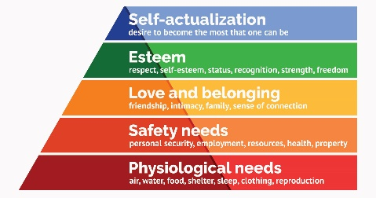

What are the things that actually motivate us to act? Throughout history, psychologists have proposed different theories to explain what motivates human behavior. The following are some of the major theories of motivation.

**Content theories:**

* Maslow's hierarchy of needs. Abraham Maslow postulated that a person will be motivated when his needs are fulfilled
* Hertzberg's two factor theory
* McClelland's theory of needs

**Process theories:**

* Vroom's theory of expectancy
* Adam’s equity theory
* Goal setting theory
* Reinforcement theory

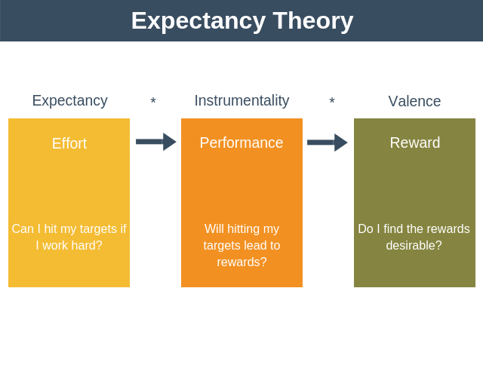

**Importance of Motivation @work place (Source ResearchLEAP)**

Motivation can emanate from with an employee with a passion and desire to work and produce results. This kind of motivation is self-driven by an employee in order to elevate his feelings to accomplish.

**Application of Motivational Theories @work (Source ResearchLEAP)**



I have selected three high profile theories offering an interesting take on what motivates different individuals.

**Maslow’s Hierarchy of Need**. These categories, in order of decreasing priority:

* physiological needs (food, shelter, clothing).
  + safety and security needs (physical protection).
  + social needs (association with others).
  + esteem needs (receiving acknowledgement from others) and
  + self-actualization needs (the desire for accomplishment or to leave behind a legacy).

Maslow’s hierarchy of needs forms the basis of theories that try to explain job satisfaction.

***Personal work life examples:***

*I work for a manufacturing Industry, hence would like to differentiate the motivation levels between blue collar and white collar colleagues.*

*If we look at the first two needs, I could relate it mostly with the factory workers (blue collar employees), since their day-to-day task is almost fixed, they look to satisfy only their basic needs for survival. Whereas, if we look at the white collar employees (sales, customer service, finance colleagues) the social needs, esteem needs, self-actualization needs plays a very important role in maintaining their motivational levels.*

**McClelland’s Needs Achievement Theory:**

McClelland’s need achievement theory postulates that some people are driven to success through seeking “personal achievement rather than rewards themselves”).

**Application:**

Although I don’t have a personal example, at work place this theory is readily applicable to startups founders. Despite the difficulties they face, they set themselves high goals and achieving these goals is what drives them. It also applies to sports personalities, corporate visionary leaders like J.R.D Tata, Azim Premji etc.,

**Herzberg’s Two-Factor Theory/Motivator-Hygiene:**

Herzberg’s Two-factor theory, also known as Motivator-Hygiene. Regarding ‘satisfiers’, Herzberg noted that there were five features of work that bring about satisfaction, namely achievement, recognition, the job itself, responsibility and advancement. Organizations are increasingly applying Herzberg’s theory to create opportunities for “personal growth, enrichment and recognition” among their employees.

***Personal work life examples:***

*Personally, I have worked for fifteen years in one single organization. One of the main reasons for my long stint in the organization was the opportunities to learn and grow within the organization, by moving into other functions and taking up leadership responsibilities in those functions. I started out in customer service function and then moved in to sales function and was also given the opportunity to lead the supply chain function. By allowing to work with diverse teams, the organization was able to enrich my work experience during my tenure.*

**Conclusion:**

Motivation is very much needed for employees in an organization to be productive, and management or leadership style has an important role to play. Through a detailed study on application of various theories it can be concluded that motivation is based on financial rewards and non-financial rewards methods. Although all individuals have their own expectations, it is the leadership’s responsibility to develop and align with theories that are suitable to bring job satisfaction to their employees. However, there is no single reliable theory to be used, a mixture of them can be utilized depending on the nature of work and people.